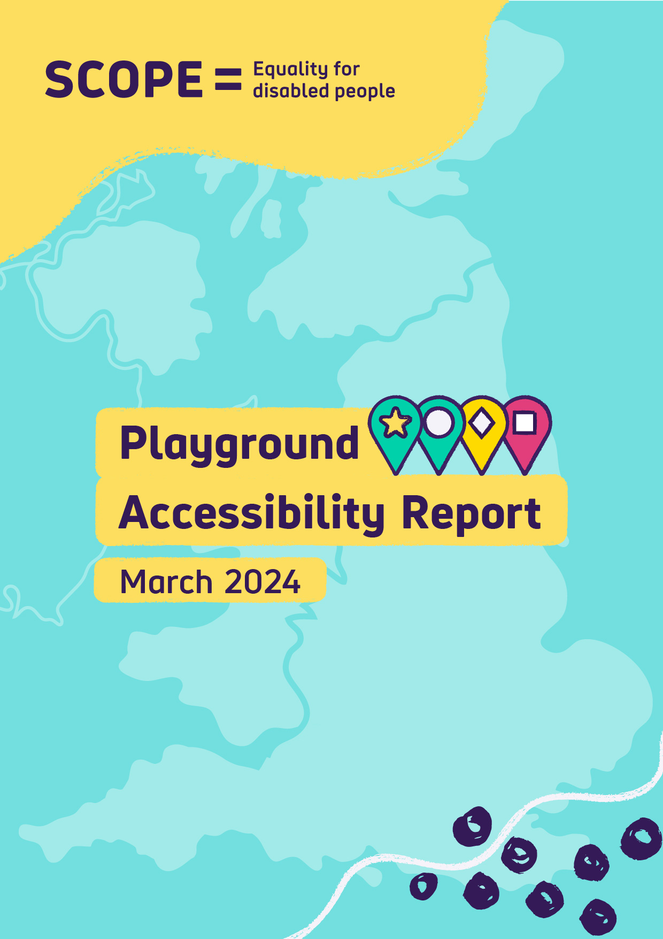

Contents

The headlines 3

Introduction to Let’s Play Fair 4

The Play Investigation 5

How to use this report 6

Results of Play Investigation 8

Proportion of inclusive playgrounds regionally 8

Most common features that make a playground inaccessible 9

Inclusive and accessible features 10

Data methodology 11

Contact us 16



The headlines

Only 1 in 10 playgrounds are inclusive

The Play Investigation, our national survey of playgrounds, finds that only 11 per cent of playgrounds met our threshold of Green for accessibility and inclusivity. Green playgrounds have many accessible features, and many features which make them inclusive play spaces. This means that only 1 in 10 playgrounds are spaces where disabled children can get in, move around and play in the playground.

Nearly half of playgrounds are inaccessible

47 per cent of playgrounds were ranked Red. Red playgrounds are those with few accessible features, or had a feature that made them inaccessible. Red playgrounds are places where disabled children would struggle to get into and around the playground and would be unlikely to be able to play.

Introduction to Let’s Play Fair

Let’s Play Fair is Scope’s campaign calling for disabled children to be given an equal chance to play. Every child has an equal right to play. Play feeds imagination and forms friendships.

Inclusive playgrounds would mean that all children can be themselves and form memories that last a lifetime.
But local playgrounds haven’t been designed with disabled children in mind.
The Let’s Play Fair campaign calls for national and local action for inclusive playgrounds.
- We call on the Government to produce guidance and provide funding to local Government so that they can create inclusive playgrounds.
- We call on local authorities to work with disabled children and their families to plan and create inclusive playgrounds. Playgrounds that meet the needs of disabled children and promote inclusivity.
Inclusive playgrounds nurture disabled children’s emotional, mental, and physical development. They create a sense of belonging for families with disabled children in their communities. And they enable disabled and non-disabled children to play together, breaking down barriers.

How we use the terms inclusive and accessible playgrounds
Playgrounds should be both accessible and inclusive.

Accessibility is about removing barriers that may prevent disabled children from taking part.

Inclusion is about going a step further. It’s not just about removing barriers, but introducing opportunities for play that ensures that disabled children are included. It’s about promoting integration, creativity and fun - playgrounds that disabled children can truly enjoy and engage fully in.

This report addresses both accessibility and inclusivity. For example, where we discuss playgrounds being inaccessible, there are barriers to disabled children taking part. If they are not inclusive, there may not have sufficient opportunities for play and integration.

This report summarises the evidence collected from our Playground Accessibility Map and shows just how limited the number of inclusive playgrounds across the country is.

The Play Investigation

In August 2023, we launched The Play Investigation. The Play Investigation was an online survey to discover how inclusive and accessible playgrounds are for disabled children. By answering a few short, simple questions at a local playground, people across the United Kingdom told us about their local playgrounds.

The Investigation was developed in partnership with PiPA Play – an organisation led by a parent of a disabled child, that works to support those seeking to plan and create inclusive play areas.

The Play Investigation asked a series of questions designed to identify features which made playgrounds more, and less, inclusive and accessible. Questions covered:
- Environment of the park, such as surfaces, gates, fences and toilets
- Features at the park, such as sensory equipment, inclusive traditional play equipment, and specialist disability play equipment
- How those with lived experience felt about the inclusivity at the playground
- If the Play Investigation increased knowledge of inclusive playgrounds

The results of The Play Investigation form The Playground Accessibility Report. The Report shows the scale of inaccessibility and the lack of inclusive playgrounds. It shows the limited options available where disabled children can play and feel a part of their community.

The Play Investigation opened on 18 August 2023 and ran until 8 January 2024. In that time, 1083 Play Investigation surveys were conducted at 1004 playgrounds. Some playgrounds were surveyed more than once.

The Play Investigation was designed to be taken by the public, including by those with no knowledge of disability and accessibility. Questions were designed to be simple and easy to answer.

Let’s Play Fair and The Play Investigation both take a universal design approach. Universal design is the concept that by creating environments that are accessible to disabled people, more people overall can use the space.

This Universal Design approach ensured we looked at features that would improve the inclusivity and accessibility of children with the broadest range of conditions and impairments. These included looking at sensory needs, safety, visibility, mobility requirements and being step-free.

How to use this report

This report is designed to be used alongside the Playground Accessibility Map. The Playground Accessibility Map can be used to search in your local area and find your nearest inclusive playground. It can also be used to show your local council the state of play in your area.

This report shares the results of The Play Investigation, breaking down some of the key findings. This report is designed to help you understand the results, and local and national pictures, and be able to give some more detail.

Throughout this report, we refer to playgrounds as Red, Amber, Green and Green Star. The meanings of the colours/ratings in this report are:
- Red: The playground is unlikely to be accessible to most disabled children, and doesn’t have much equipment for them to play with.
- Amber: This playground is likely to be reasonably accessible to most disabled children, but there might not be much for them to enjoy.
- Green: This playground is likely to be accessible to disabled children, and has some equipment they can play with.
- Green Star: This playground is likely to be accessible to disabled children, and there’s lots for them to enjoy.

We discuss how we determined these ratings in the data methodology section of this report.

As well as containing our findings, this report also includes some discussion about how data was handled, how criteria were determined, and answers some questions about the data.

Other materials have been produced as part of the Let’s Play Fair Campaign, including
- Playbook: An inside look at inclusive playgrounds - polling data, stories from parent carers and case studies of inclusive playgrounds
- Campaigning for Inclusive Playgrounds guide – Support to make inclusive playgrounds happen in your area. A version specifically for councils is available from publicaffairs@scope.org.uk.
- Play Investigation: Explainer – Why certain features at a playground are more or less inclusive than others, and what universal design is.

Please credit Scope’s Playground Accessibility Report (March 2024) when citing this report. Please contact us at campaigns@scope.org.uk to share how you plan to use it.

Results of Play Investigation

The results of the Play Investigation show that in England and Wales, every region has more inaccessible playgrounds than accessible and inclusive playgrounds. Overall, just one in ten playgrounds are inclusive.

Proportion of inclusive playgrounds regionally

 |  | Green Star | Green | Amber | Red
Region
 | East Midlands | 0% | 5% | 45% | 50%
 | Eastern | 2% | 10% | 48% | 40%
 | London | 0% | 11% | 44% | 45%
 | North East | 0% | 14% | 35% | 51%
 | North West | 0% | 8% | 50% | 42%
 | Northern Ireland | 0% | 0% | 67% | 33%
 | Scotland | 0% | 43% | 14% | 43%
 | South East | 1% | 16% | 33% | 50%
 | South West | 0% | 7% | 41% | 52%
 | Wales | 2% | 5% | 52% | 41%
 | West Midlands | 1% | 13% | 30% | 56%
 | Yorkshire and the Humber | 0% | 14% | 37% | 49%
 | National Proportions | Less than 1% | 11% | 42% | 47%

From this, we can see that the South East, North East, West Midlands and Yorkshire and the Humber have the highest proportion of inclusive playgrounds in England and Wales.

The West Midlands, South West and North East had the highest proportion of inaccessible and non-inclusive playgrounds in England and Wales. The West Midlands and North East feature on both lists due to their relatively low proportion of Amber playgrounds, which are playgrounds with some inclusive features but not enough to be considered accessible or inclusive playgrounds.

Most common features that make a playground inaccessible

Alongside PiPA Play, we determined that the following features would mean that regardless of the rest of the playground and its equipment, it would be inaccessible from a universal design perspective. This meant that if a playground had one of these features, it would be considered Red.
These features were:
- The gate into the playground not being wide enough for a wheelchair user to fit through
- The paths and entrances to the playground not being flat and step-free
- The paths within the playground not being flat and step-free
- The flooring is either sand or loose wood chip
- Not being able to reach any of the equipment without using steps

The proportion of playgrounds with these features:

Inaccessible features
There is no path to the playground | 30%
There are no paths within the playground or to the equipment | 20%
The gate into the playground is not wide enough for a wheelchair user to fit through | 18%
None of the equipment in the playground can be reached without steps. | 16%
The main surface in the playground is woodchip | 13%
The main surface in the playground is sand | 3%

Inclusive and accessible features
Certain features can be considered inclusive or accessible. This chart shows the proportion of playgrounds with these features.

Features | Proportion
A fence around the playground | 80%
A gate wide enough for a wheelchair user to fit through | 76%
A bench near the main equipment | 76%
The main surface is a softer, rubbery floor | 61%
A bench away from the main equipment | 55%
A swing with a large nest, bucket or flying saucer shaped seat you can lay down in | 45%
Some natural landscaping, such as trees to play hide and seek in or mounds to roll down | 41%
A roundabout with seats | 33%
A roundabout that is flat to the ground | 25%
A quiet area, like a tunnel or play house to hide in | 25%
Clear colour contrast around the equipment | 23%
Boards or panels with activities or games on | 22%
A swing with a high back, a bit like a car seat, that an older or larger child could fit on | 15%
A garden, with plants to smell and touch | 13%
An accessible toilet | 10%
Musical and sound equipment like drums, xylophones or things that rattle | 10%
An in-ground trampoline that two people could jump on at the same time | 9%
A contained, step-free sandpit or sandy area | 7%
A playhouse that is step-free | 6%
A smooth, wide ramp up to the play structure | 5%
Water features to play in | 5%
A seesaw with seats which have a back | 5%
A seesaw with a flat surface that children can stand, lay or sit in a wheelchair on | 4%
Boards or panels with lights, things to touch or sounds | 3%
Mirrors | 3%
A wheelchair swing | 2%
A changing places toilet | 1%
The most common of these features are:
- A fence around the playground
- A gate wide enough for a wheelchair user to fit through
- A bench near the main equipment

Data Methodology

Assigning Scores
To gain insights from The Play Investigation data, answers were assigned numerical scores on a 0/5/10/15 scale. Scores were awarded as follows:
- 0 points were scored if a feature was absent, or the least accessible option
- 5 points were scored for a feature which is largely inaccessible
- 10 points were scored for a feature which is mostly accessible and inclusive
- 15 points were scored for a feature which was largely accessible and inclusive.

Scores were assigned in multiples of 5 to keep a clear scale.

Questions and responses, and the subsequent scoring, were determined by the PiPA Play principles, our work with parents and early report, The Playbook. The information in the Play Investigation: Explainer also gives insight into the inclusivity and accessibility of different equipment, which informed scores.

Assigning Rankings
We determined a minimum score required for Amber and Green scores. We did this by modelling a minimum score for the grades. If a playground did not reach Amber, it would be considered Red.

We also determined criteria that would lead to a playground being inaccessible to disabled children, regardless of other features. This “fail” criteria is shown on page 9, and would result in a playground being given a Red ranking.

If a playground had the following features or alternative inclusive features with the same score, it would reach Amber:
- The presence of a fence
- The presence of a gate wide enough for a wheelchair user to get through
- Paths to the playground
- Paths within the playground
- Faded or unclear colour contrast around equipment
- The main surface of the playground was at least as accessible as grass
- Benches away from the equipment
- A non-accessible toilet
- A handrail on the play structure
- Play value on the play structure, such as wheels to turn or puzzles
- At least one safe, inclusive swing seat (car-seat style, or bucket swing)
- Some, but less than half of the equipment is step-free.

This criteria led to a minimum score of 100 for a playground to achieve above an Amber ranking.

As the rating was score-based, there may be some playgrounds which do not have these features, but which reach this score. For example, if a playground met all other criteria but did not have a toilet, but did have a piece of inclusive equipment worth 10 points, it would still achieve Amber. Every playground is different, and this scoring system accommodates that.

The minimum score for a playground to reach a Green rating was similarly decided. The criteria that were included in the score were:
- The presence of a fence
- The presence of a gate wide enough for a wheelchair user to get through
- Paths to the playground
- Paths within the playground
- Clear colour contrast
- The main surface is concrete or a softer, rubbery floor
- Benches away from the main equipment
- An accessible toilet
- Step-free roundabout access
- A ramp to the play structure
- A handrail on the play structure
- Play value on the play structure, such as wheels to turn or puzzles
- At least one safe, inclusive swing seat (car-seat style, or bucket swing)
- More than half of the play equipment is step-free
- There are at least 2 pieces of sensory equipment
- There is at least one piece of inclusive equipment
- A slide wide enough for a parent to go down with a child, or for two people to go down it together.

These criteria set a minimum score of 185 for a playground to be ranked Green. As with Amber playgrounds, this score may come from a combination of features other than this exact list, but the score must be made up of other accessible or inclusive features. This means that these playgrounds are likely to be mostly accessible to as many children as possible. These playgrounds will also have as many inclusive play opportunities as possible.

Green Star Playgrounds

For a playground to achieve a green star, the following criteria needed to be met:
- The playground was ranked Green
- The playground had to have a fence around it, and a gate wide enough for a wheelchair user to get into the playground
- The path inside the playground had to be wide enough for a wheelchair user to navigate it
- There must be clear colour contrast between paths and equipment
- If a playground had no benches at all, it was excluded from being able to reach Green Star
- Similarly, no toilets at all was an exclusion from being eligible for a Green Star
- A Green Star playground must have an accessible or changing places toilet
- There needed to be at least two pieces of sensory equipment, not including benches.
- There needed to be at least 3 pieces of inclusive equipment, such as:
  - A contained, step-free sandpit or sandy area
  - A playhouse that is step-free
  - An in-ground trampoline that two people could jump on at the same time
  - Musical and sound equipment like drums, xylophones, or things that rattle
  - Boards or panels with activities or games on
  - Boards or panels with lights, things to touch or sounds
  - Mirrors
- There needed to be at least 3 of the following:
  - Step-free access to the slide
  - Flat to the ground roundabout access
  - A smooth, wide ramp to the play structure
  - A swing seat with a high back, a bit like a car seat, that an older or larger child could fit on
  - A swing with a large nest, bucket or flying saucer shaped seat that you can lay down in
  - A wheelchair swing
  - A changing places toilet
- Any playground where less than half of the equipment could be reached without steps was also excluded.

These criteria identify playgrounds which, as far as possible, follow the universal design principle. They are not only as accessible as possible, but they also feature elements of the playground which means disabled children can join in with play on as many different pieces of equipment as possible.

How data was collected

The Play Investigation was carried out by over 1000 members of the public using an online survey, The Play Investigation. 49 per cent of people answering The Play Investigation declared themselves to be disabled, parents of disabled children, or both.

Whilst the questions were designed to gather reliable, objective data, there is a chance that questions have been misinterpreted or incorrectly answered. Scope has not verified the data provided by the public.

All information is gathered from the subjective experience of people answering the survey.

As a result, there may be some elements of the data that may be subjective or incorrect in the Playground Accessibility Map specifically. Playgrounds may also have changed since The Play Investigation was completed.

Duplicate Playgrounds
Where more than one campaigner investigated the same playground, we combined their answers into a single response. We identified duplicate playgrounds through the location data campaigners provided us with.

To try and get the most appropriate data from duplicated playgrounds:

- We used answers that matched up, taking the consensus to be true.
- Where one campaigner left an answer blank, and the other answered the question, we took the completed answer as true.
- Where there wasn’t a majority consensus, we used Google Maps images to see which answer seemed more accurate.
- Where there wasn’t a majority consensus, and we couldn’t find evidence on Google Maps, we used the higher scoring answer.

Where multiple campaigners gave different answers to the question asking how easy or difficult they thought it’d be for disabled and non-disabled children to play in the playground together, we combined the answers to form an average. Where they gave the same answer, we took the consensus to be true.

Where multiple campaigners provided open text comments about the playground, we included all the comments. While keeping in line with our policy of editing or removing any comments that were offensive, contained personal detail, or were otherwise irrelevant.

In the final data, we recorded the date of the most recent play investigation in each playground.

Small Playgrounds

If a playground was too small to have lots of different kinds of equipment, it may have scored low and resulted in an unrepresentative grade. We didn’t want this to be a penalty in being able to score what was there appropriately.

We identified small playgrounds that fit the following criteria:
- An amber rating (to ensure that the playground had the minimum accessibility standards)
- No fails
- Over 40% of their overall score consisted of points from sensory equipment, inclusive equipment, and/or a wheelchair swing.

We felt these playgrounds, while small, were likely to be accessible to disabled children. They also had a reasonable number of inclusive features for their size. Their only limitation appeared to be not having as much equipment overall.

We identified 3 playgrounds that met these criteria. We used Google Maps to estimate the size and quality of the playground. We awarded 2 of these playgrounds a ‘small playground bonus’. We amended their rating to green.

Contact us

This report was produced by Scope in March 2024. Please contact campaigns@scope.org.uk for further information.

This report primarily focuses on England and Wales. Scotland had 7 playgrounds investigated, and Northern Ireland had 3. We have shared the data we have available, but we have kept our analysis in this report primarily about England and Wales.
In regards to the paths within the playground not being flat, if the playground has a soft, rubbery floor it therefore doesn't need to have paths and therefore did not automatically become Red.

